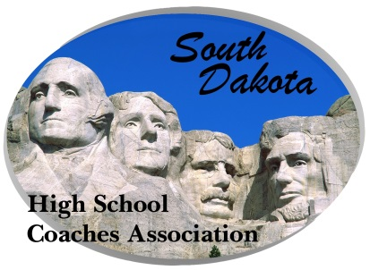**South Dakota High School Coaches’ Association**

**801 W Eagle Ridge Street**

#### Sioux Falls, SD 57108

**(**[SDHSCA@k12.sd.us](mailto:SDHSCA@k12.sd.us)**)**

**Federal Non-profit ID#: 23-7297479**

FOR IMMEDIATE RELEASE:

Sioux Falls, SD – The South Dakota High School Coaches Association announces the Coach of the Year Awards for the Fall of 2023. (Other nominees are listed below each winner):

Cheer – Eve Langerock of Harrisburg High School

Val Ewing-Winner Area, Casie King-Sioux Valley, Diedra Nissen-Sioux Falls Jefferson, Quiana Pardee, Sioux Falls Roosevelt

Dance – Amanda Stoeser of Pierre High School

Carey Baczwaski-Dakota Valley, Ashley Hoffman-Brandon Valley, Tressa Tringle-Sioux Falls Roosevelt

Girls’ Soccer – Scott Mullenmeister of Mitchell High School

Mark Anderson-Tea Area, Abby Berke, Sioux Falls Lincoln, Eric Christensen-Harrisburg, Luis Usera-Rapid City Stevens

Boys’ Soccer – Curt Nelson of Vermillion High School

Ryan Beier-O’Gorman, Steven Hirsch-Sioux Falls Jefferson, Alex Nelson-Sioux Falls Lincoln

Girls’ Cross Country – Jessica Larson of Potter Country High Schools

Holly Evans-Chamberlain, Tony Thoreson-Brandon Valley, Andy Vandeest-Spearfish, Luke VanderLeest-Sioux Falls Christian

Boys’ Cross Country – Ralph Kroetch of Philip High School

Luke Jelen-Sioux Falls Lincoln, Joey Noyes-Hill City, Blake Proefrock-Sturgis, Eric Townsend-Milbank

Football – Ben Kramer, Hot Springs

Jared Fredenburg-Sioux Falls Lincoln, Matt Grave-Parkston, Kerwin Hoellein-Warner, Jordan Huska-Dell Rapids

Volleyball – Jean O'Hara of Chester Area High School

Ronette Costain-Harrisburg, Kari Jung-Warner, Darci Wassenaar-Sioux Falls Christian, Krystal Weber-Rapid City Christian

Last year’s winners:

Cheer – Cami Bacon of St. Mary’s High School

Dance – Lynsey Andal of Beresford High School

Girls’ Soccer – Mark Anderson of Tea Area High School

Boys’ Soccer – Jeff Fierro of Rapid City Stevens High School

Girls’ Cross Country – Jesse Coy of Rapid City Stevens High Schools

Boys’ Cross Country – Jesse Coy of Rapid City Stevens High Schools

Football – Lex Heathershaw of Wall High School

Volleyball – Kari Jung of Warner High School

These coaches will be recognized at the annual awards banquet on Sunday, June 16, 2024 to be held in Mitchell.

Jim Dorman, Executive Director

SDHSCA