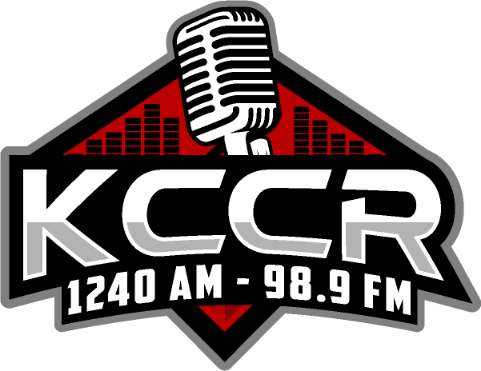

52nd Annual Farm, Home and Sport Show
Booth Confirmation
February 24th & 25th, 2024

Yes, I would like to be part of the 2024 KCCR Farm, Home & Sport Show.

Business Name:

Booth Size:

Live Interview Contact:

Live Interview Time Preference (please note live broadcasts from booths only):

Friday PM (during set up)
Saturday
Not Interested in Live Interview

Location I Prefer:
Same as last year
Main Convention Area
Hallway

Special Needs:

Owner/Manager
Signature:

Date: Phone Number:

Please return this confirmation to insure your location is reserved (booths will be guaranteed until March 15th, 2023)! If you cancel your booth after December 15th, 2023, you will be charged for the full amount. The reason for this policy is that KCCR is billed for reserved spaces. We want to maintain a full show that is enjoyable for all customers. We require that you make your payment prior to the show, unless other arrangements have been made with your sales representative. Payment arrangements can be made by contacting your sales representative.

52nd Annual Farm, Home and Sport Show

Central South Dakota’s Largest Display Show!

February 24th & 25th, 2024

Main Display Area:
8 x 8 Foot $625 40 Thirty second ads
8 x 16 Foot $875 60 Thirty second ads
8 x 24 Foot $1,125 100 Thirty second ads
8 x 32 Foot $1,375 120 Thirty second ads 8 x 40 Foot $1,625 150 Thirty second ads

Hallway Space $275 no ads included
Small Business Room $200 no ads included

End booth spaces and main/front area are an additional $50 each

Show Schedule:
Friday, February 23rd 3:00PM - 7:00PM Display Set-up
Saturday, February 24th 7:00AM - 9:00AM Display Set-up
Saturday, February 24th 9:00AM - 5:00PM Show Time
Sunday, February 25th 10:00AM - 3:00PM Show Time
Sunday, February 25th 3:05PM - 5:00PM Display Take Down

KCCR Provides:
- Complete promotion of the show
- Complete booth curtain backdrop and side drops (for booths only)
- Tables, chairs & tablecloths
- Live radio broadcasts from your booth (for booths only)

Only one business will be allowed in each booth space.

Your KCCR Account Executive is: Tara Jungwirth Steiner

